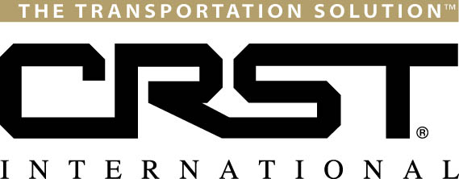
FOR IMMEDIATE RELEASE
Contact:
Brooke Willey
Vice President/Human Resources
bwilley@crst.com
(319)390-2856
CRST Logistics, Inc. Announces New Agency Partner
CEDAR RAPIDS, Iowa (September 17, 2013) – CRST Logistics, Inc, an operating subsidiary of CRST International, Inc., is pleased to announce that Top Shelf Logistics, LLC, is the most recent addition to its rapidly growing agency network.
Top Shelf Logistics is an independently owned 3PL based in Northern California, widely known as a single source, multi-modal outsourced provider of transportation and operations. Primary offerings include managing committed capacity and highly customized supply chain solutions, predominantly integrating the Wine & Spirits category in North America.
According to John Gallardo, Group President for CRST International, "The addition of Top Shelf Logistics fits well with the long term strategy of CRST Logistics. We are looking forward to utilizing the multi-modal brokerage expertise, significant relationships within the wine and spirits category, and entrepreneurial spirit with our current operation. Our diversified infrastructure, tools and significant freight spend will provide Top Shelf with the opportunity to offer their customers products and services beyond what was previously available to them".
# # #
CRST International, Inc.
Cedar Rapids, Iowa–based CRST International, Inc. is one of the largest privately-held transportation companies in the United States. Through its six operating companies, CRST provides a broad array of transportation solutions, including expedited van, flatbed, dedicated services, brokerage, transportation management, high value product white glove moving services and expedited temperature controlled team services. CRST’s operating companies are made up of CRST Expedited, Inc., CRST Malone, Inc., CRST Dedicated Services, Inc., CRST Logistics, Inc., Specialized Transportation (STI) and Temperature Controlled Team Service (TCTS). For more information, visit www.crst.com or call (800) 736-CRST (2778).

